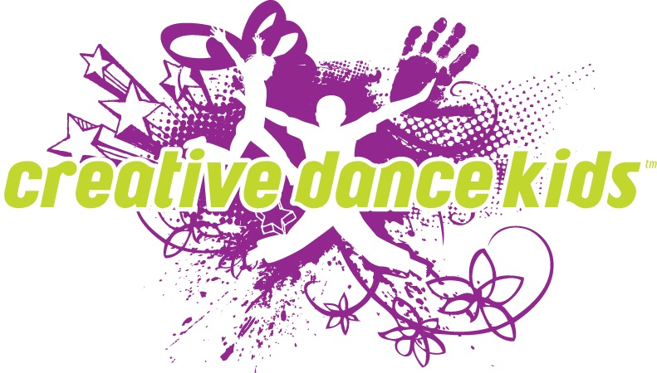

Creative Dance Kids has a limited number of scholarships available to students seeking financial aid.

If chosen, scholarship recipients are responsible for:
- Maintaining good class attendance
- Maintaining good reviews by the dance instructor

This application must be filled out by the applicant and their parent/guardian and returned to:

Creative Dance Kids
1738 Wynkoop St, #300
Denver, CO 80202

Or emailed to cdk@creativedancekids.com

Personal Information:

Student Name

Parent or Guardian’s Name

Applicant Birth date / / and Age

Daytime Phone Home Phone
Cell Phone

Address

Email

Dependents (Guardian’s or student’s if applicable)

School student Attends

Class(es) the student would like to participate in with CDK

Financial Information:

Circle all that apply to your family:

ADF Food Stamps Social Security Workman’s Comp

Unemployment benefits Free/Reduced Lunch

Government Housing Other

Student Personal Statement: Applicant should describe how he/she will benefit from this scholarship and how it will further his/her dance education. He/she could include their passion for dance, career goals, dreams, etc.

Challenges: Applicant should describe a significant setback or challenge in his/her life, the impact it has had, and the ways in which he/she are overcoming or have overcome it.

Statement of Need: Include information about your family’s need for tuition assistance. If applicable, include information and explain other forms of financial assistance you and your family receive (i.e. free school lunches, private school scholarship, tuition assistance for after school programs, etc.).

I declare that the information is true and accurate.

Signature

Date / /

---------------------------------------------------------------------------------
For office use only

